Every now and then, someone on the In Defence of Youth Work Facebook page brings up the subject of mapping youth provision around the country. So now we have decided to try to do this, using our greatest resource - you (cue motivational cheers). This involves everyone with knowledge of open access provision around their area to drop pins onto a google maps shared document, accessed here: https://drive.google.com/open?id=1h5AIffHOKF1at5HeDQuA32Uo9dA&usp=sharing

You will need a google account to edit the map, though not to see it. Otherwise it is quite simple. Upon going to the link and logging in to your google account, you should see this screen:

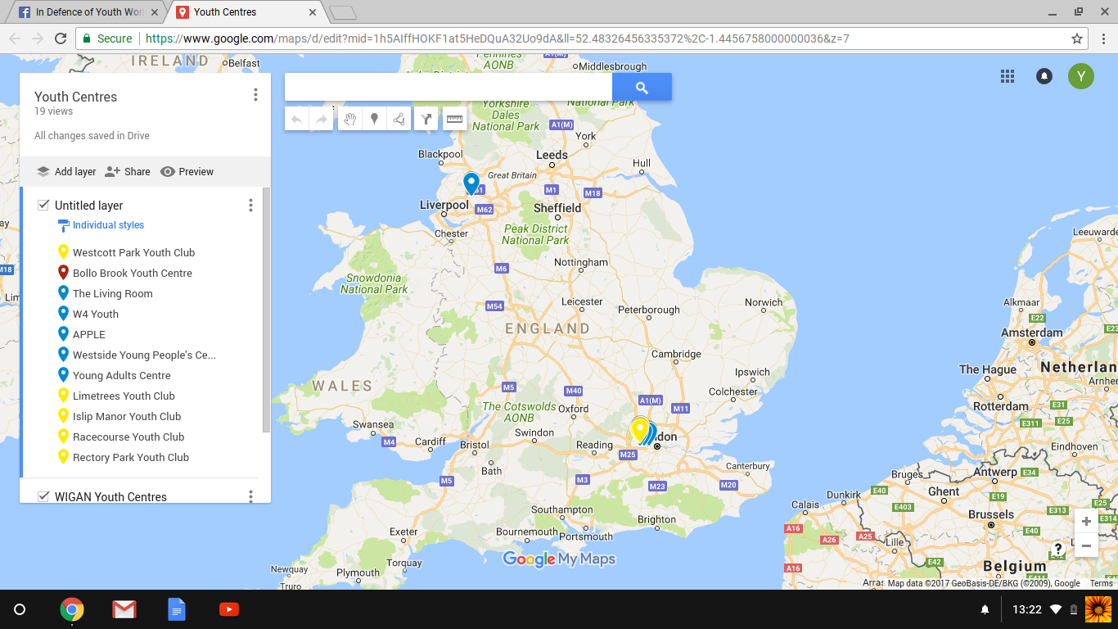

Click on the pin sign: 

This will change your cursor into a cross and allow you to drop a pin. Maneuver around the map to find the location of the club you want to add and position the cross over the building - you can zoom right in to get the exact location. When you click on it, the screen should look something like this:

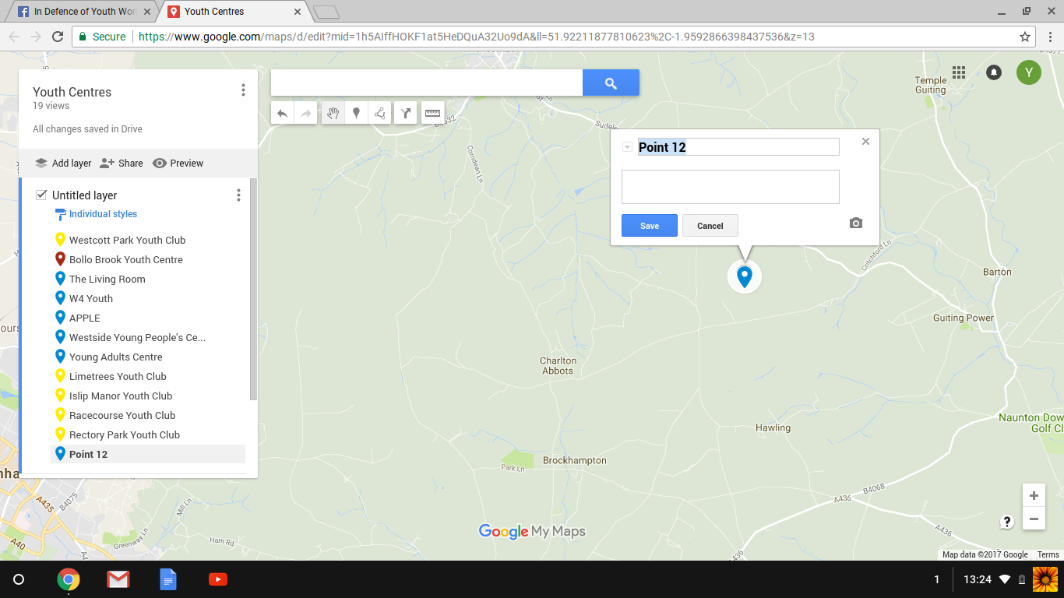

Add the name of the club and click save. You can also add a description/link to a website if you wish.

In order to differentiate between the amount of open access at the youth clubs, we are colour coding the pins. This is as follows:

- once a week sessions: yellow;
- under 10 hours of open access: blue;
- under 20 hours a week open access: green;
- over 20 hours a week open access: maroon.

Remember, this is for open access, voluntary engagement youth work only. We recognise that centres may also be used for other sessions that are by referral only, but these are not included here. To change the colour of the pin, click on it once you have saved it and click on edit. You should see this screen:

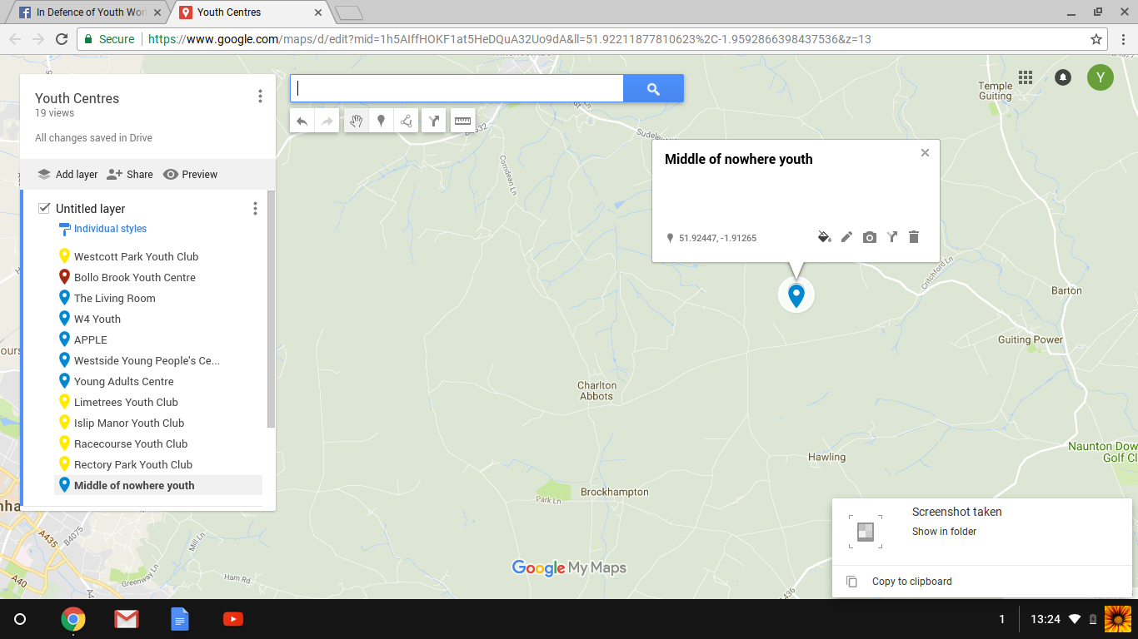

Click on the paint can in the box with the name of the club to bring up the colours and choose the one applicable to the youth club:

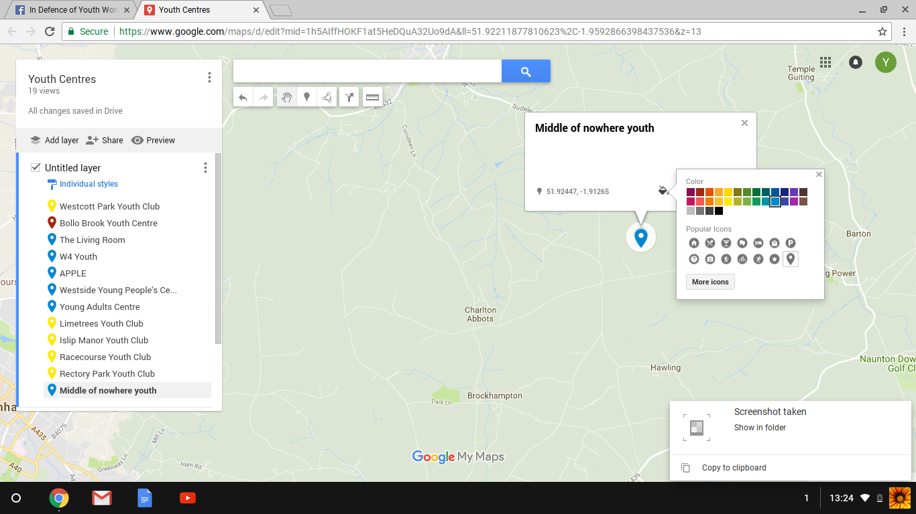

And that’s it. Now everyone with access to the map will be able to see your club. If you make a mistake, don't worry, just click on the pin and then the rubbish bin in the bottom right corner of the box.

Please share this far and wide. The more people we can get to add to the map, the more informative it will be.

Thanks.

